**Data Analyst in Power BI Data-Camp 2025**

**Section 13: Trend Analysis in Power BI**

**Exploring Time Series Data**

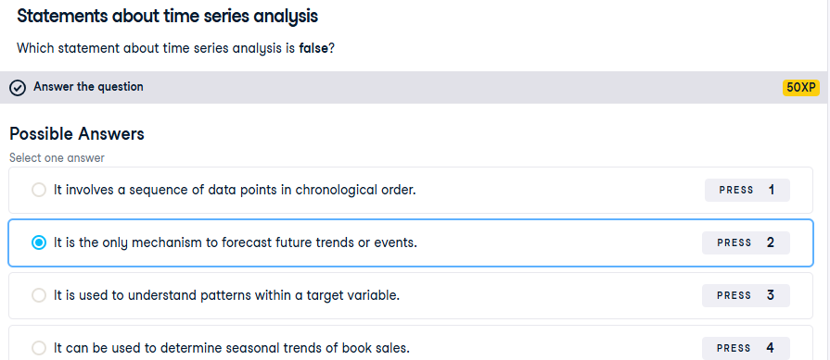

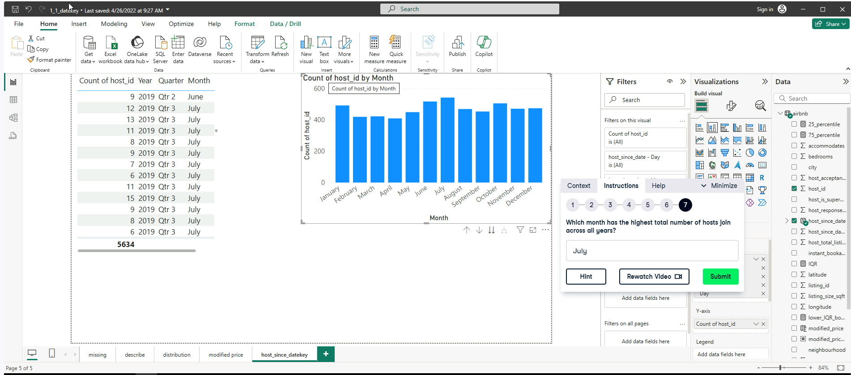

**Exercise 1.2**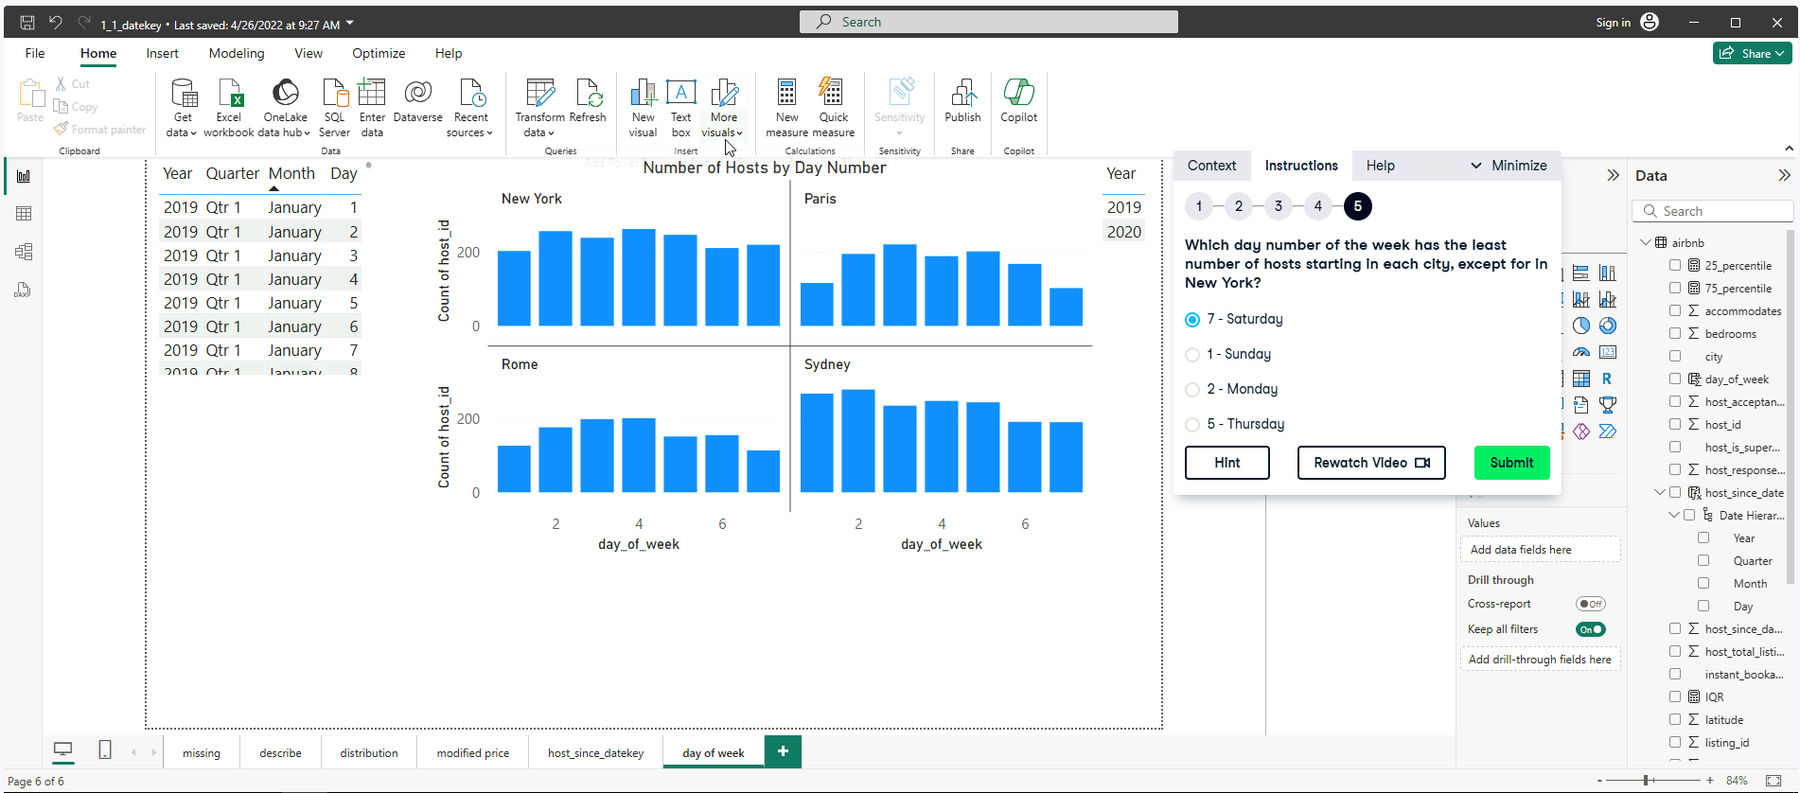

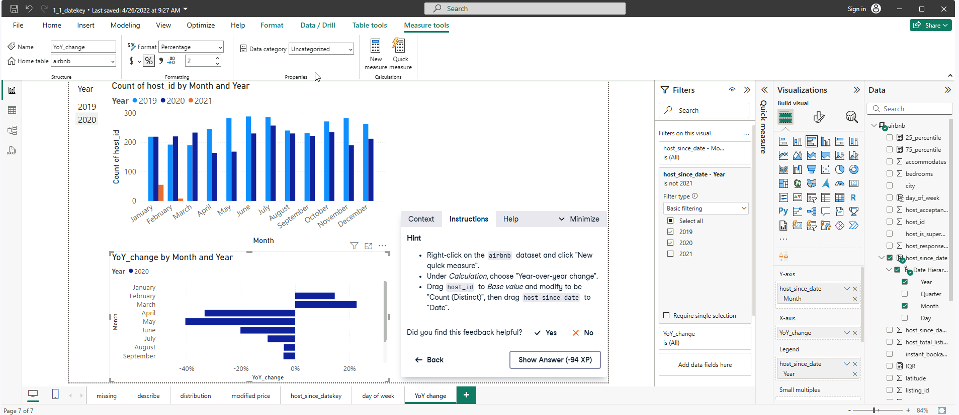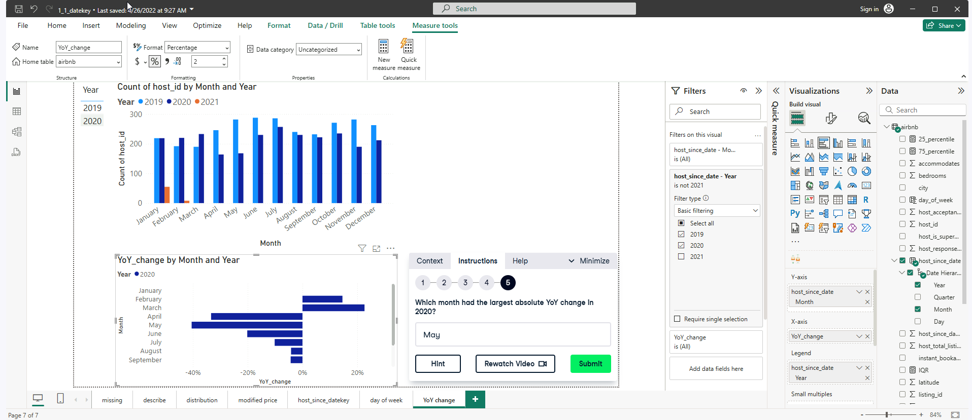

**Analyzing Time Series in Power BI**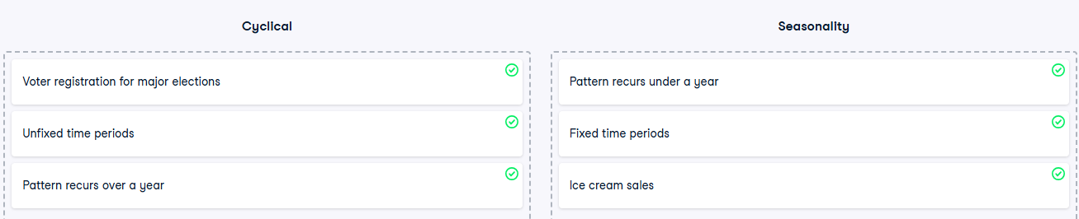

**Exercise 2.2**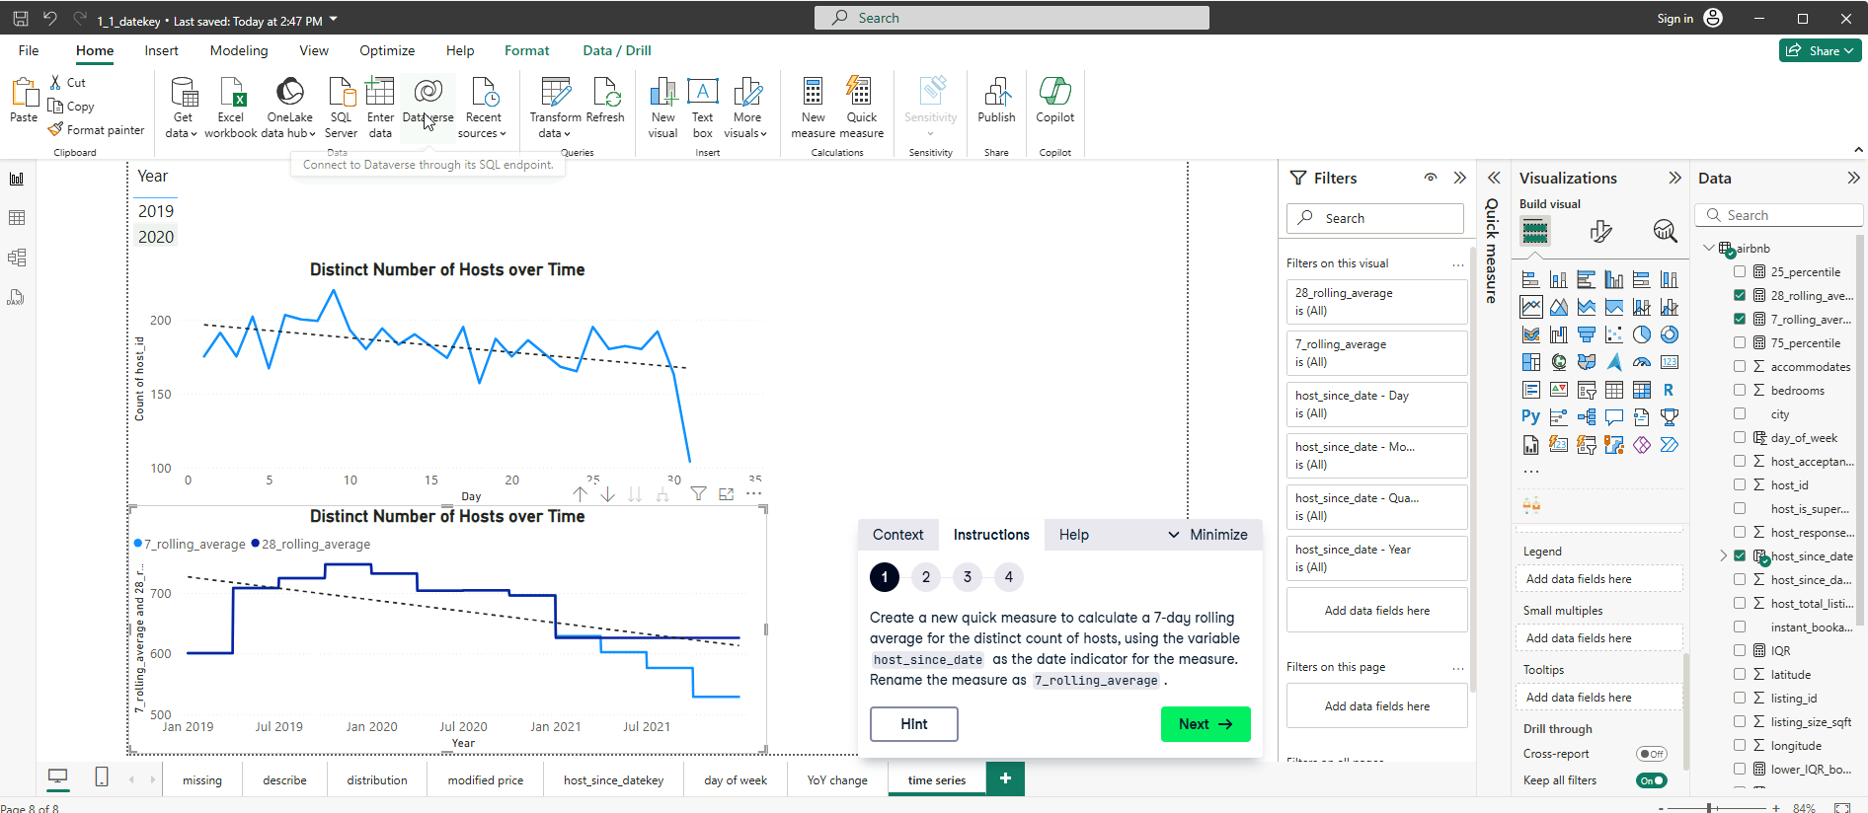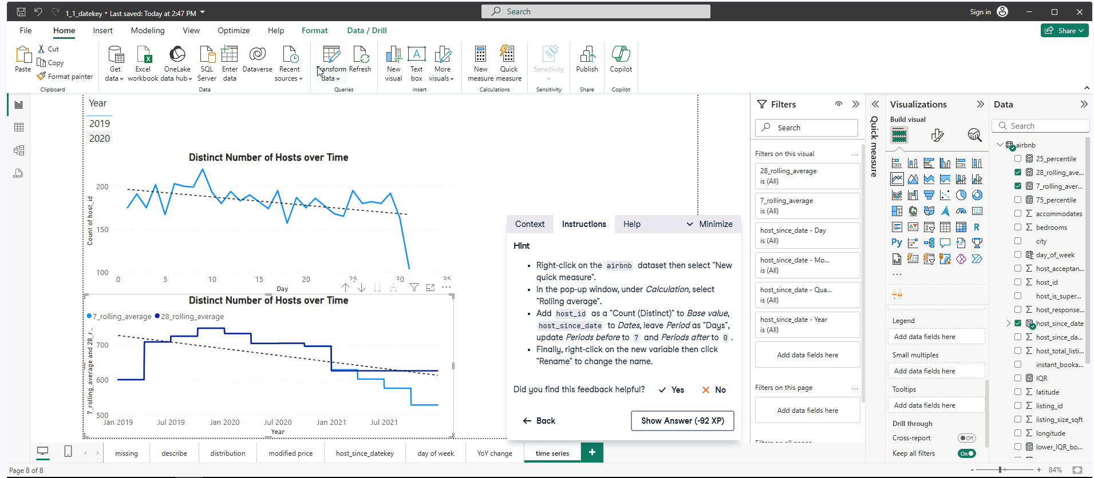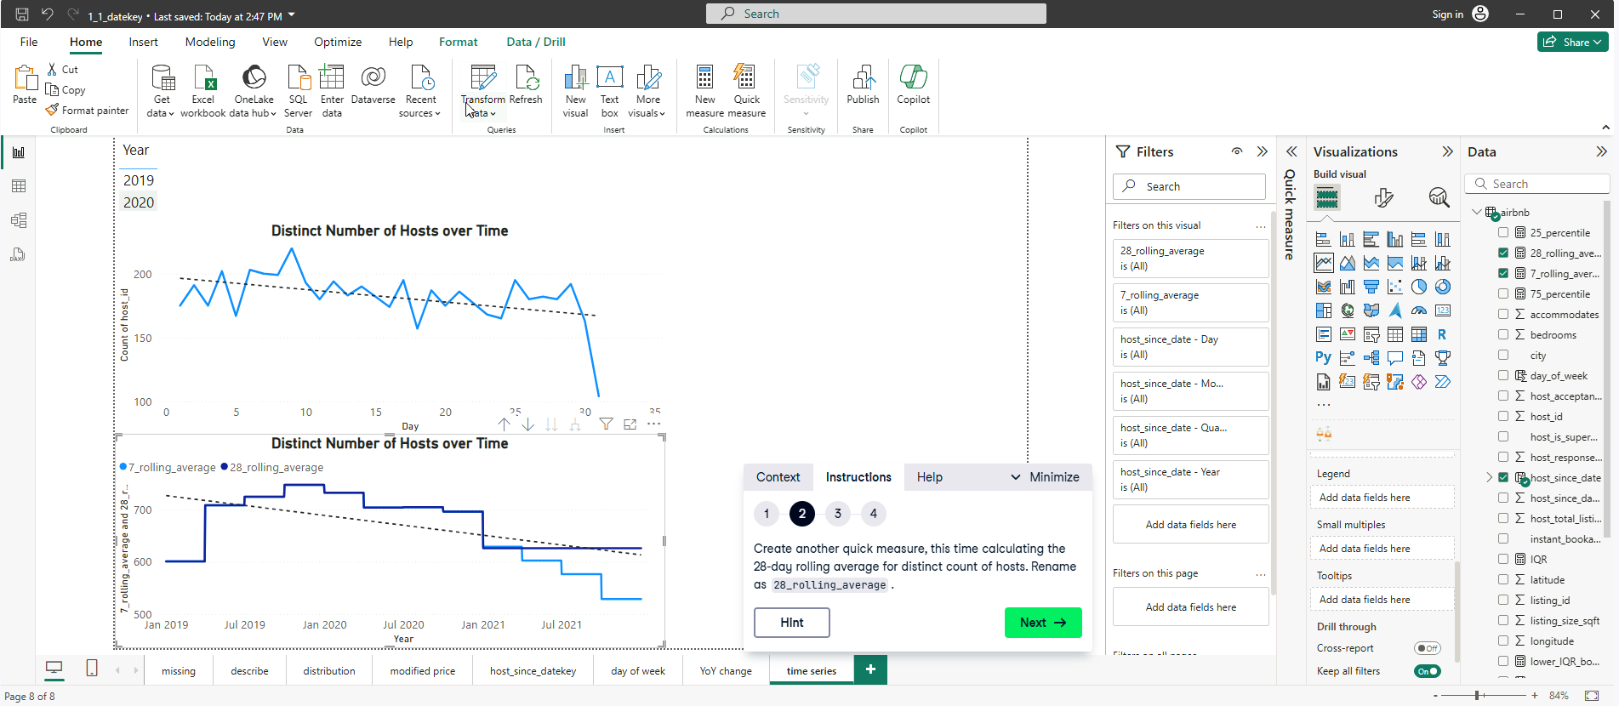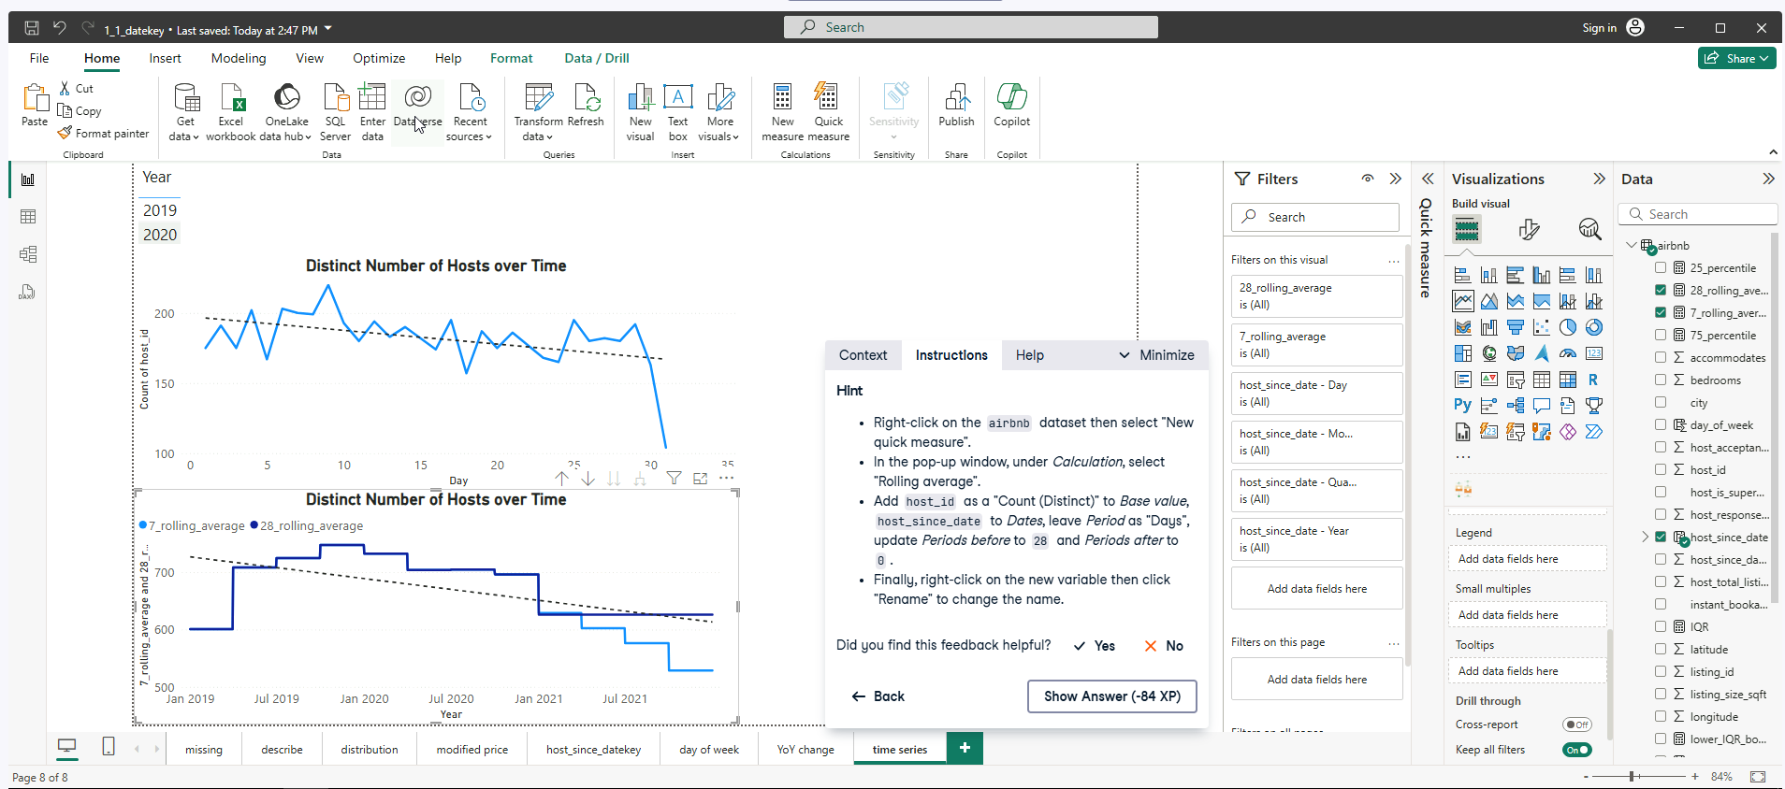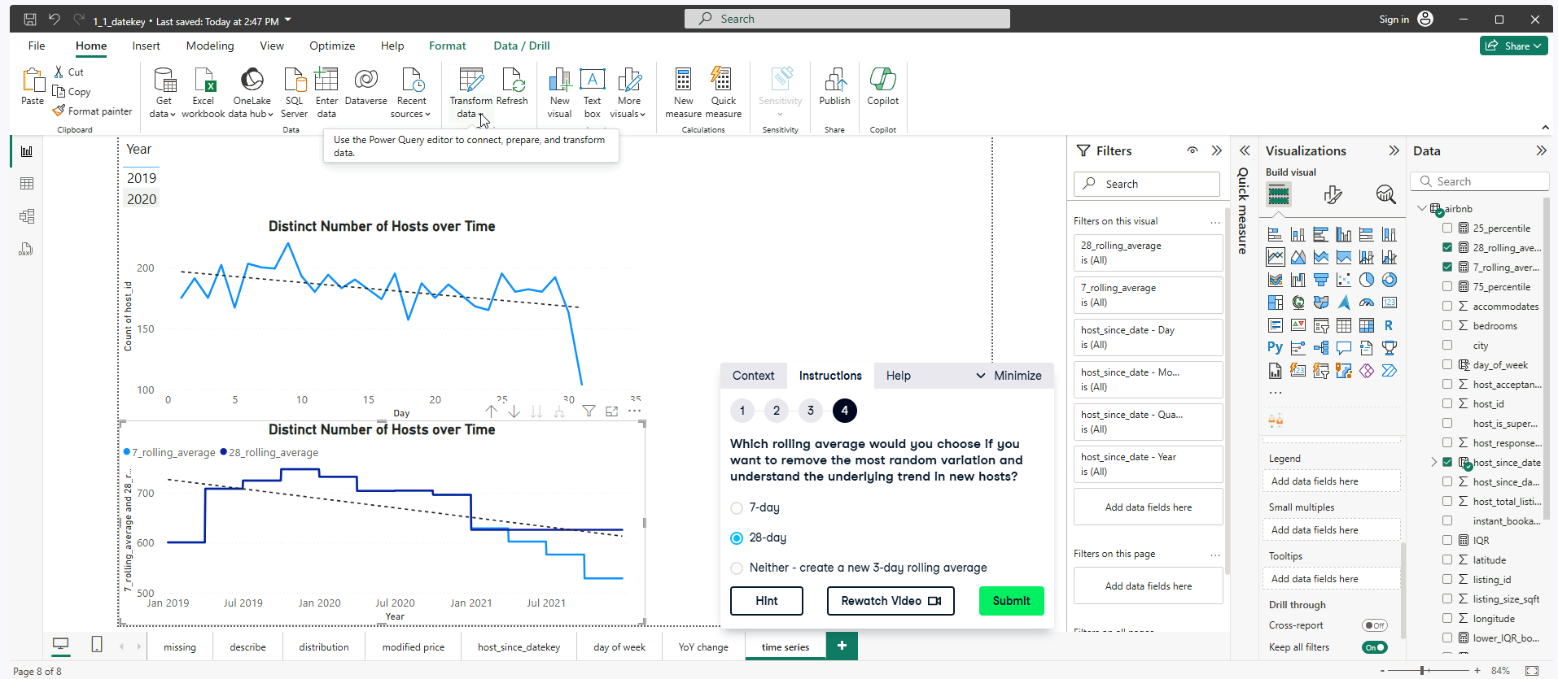

**Exercise 2.3**

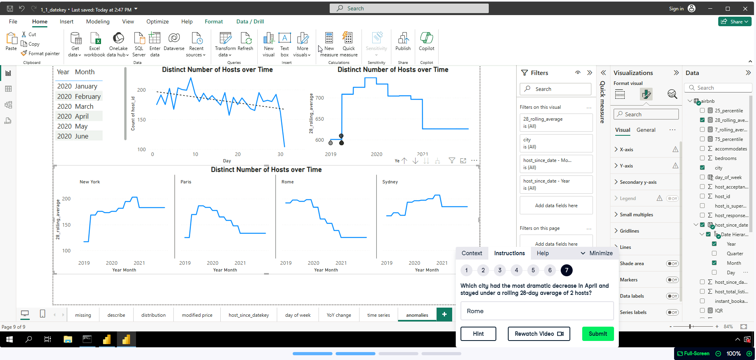

When in self-doubt:

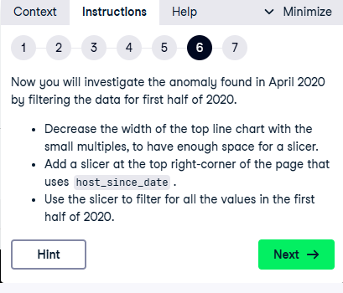

**Decomposition Trees**

**NOTE: Must Put JobLevel, JobRole, CareerStage and Gender on Explain by in that order and Analyse by Monthly Income for the Decomposition Tree. Must pick lowest value click on the + to expand these values to answer the following exercise.**

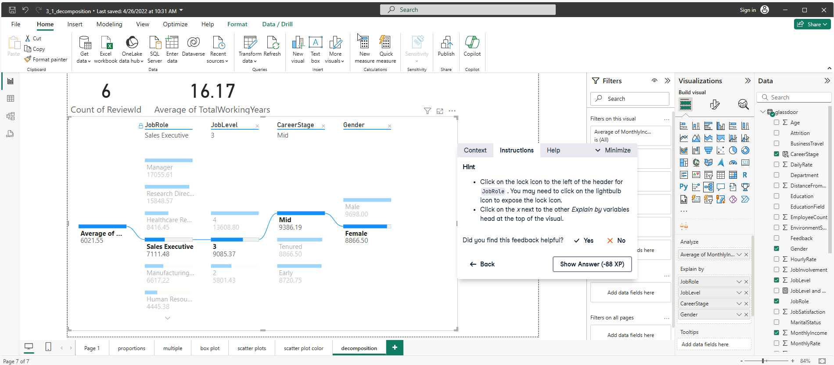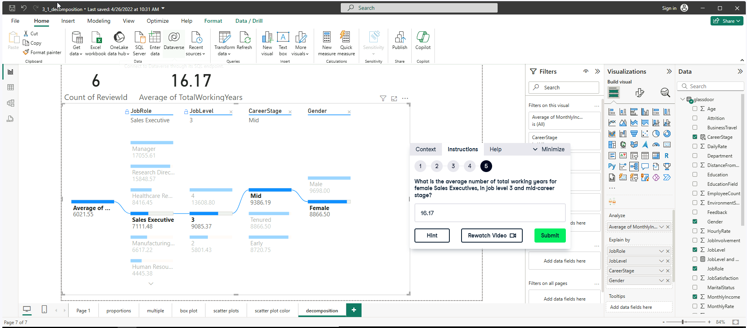

**Exercise 3.3**

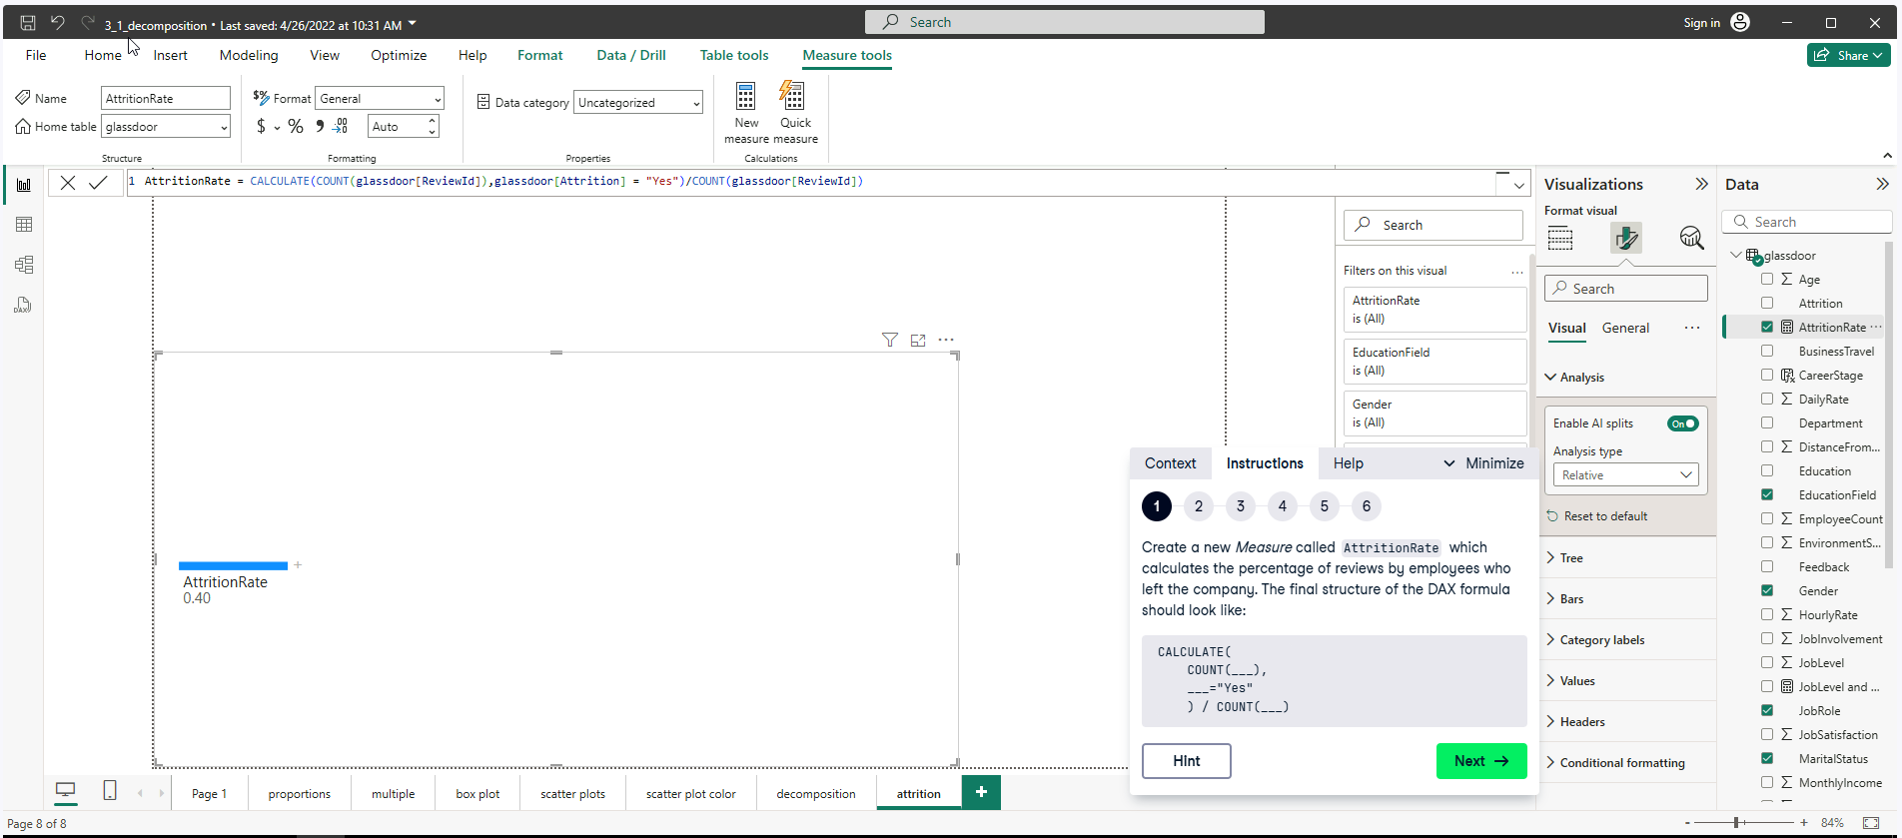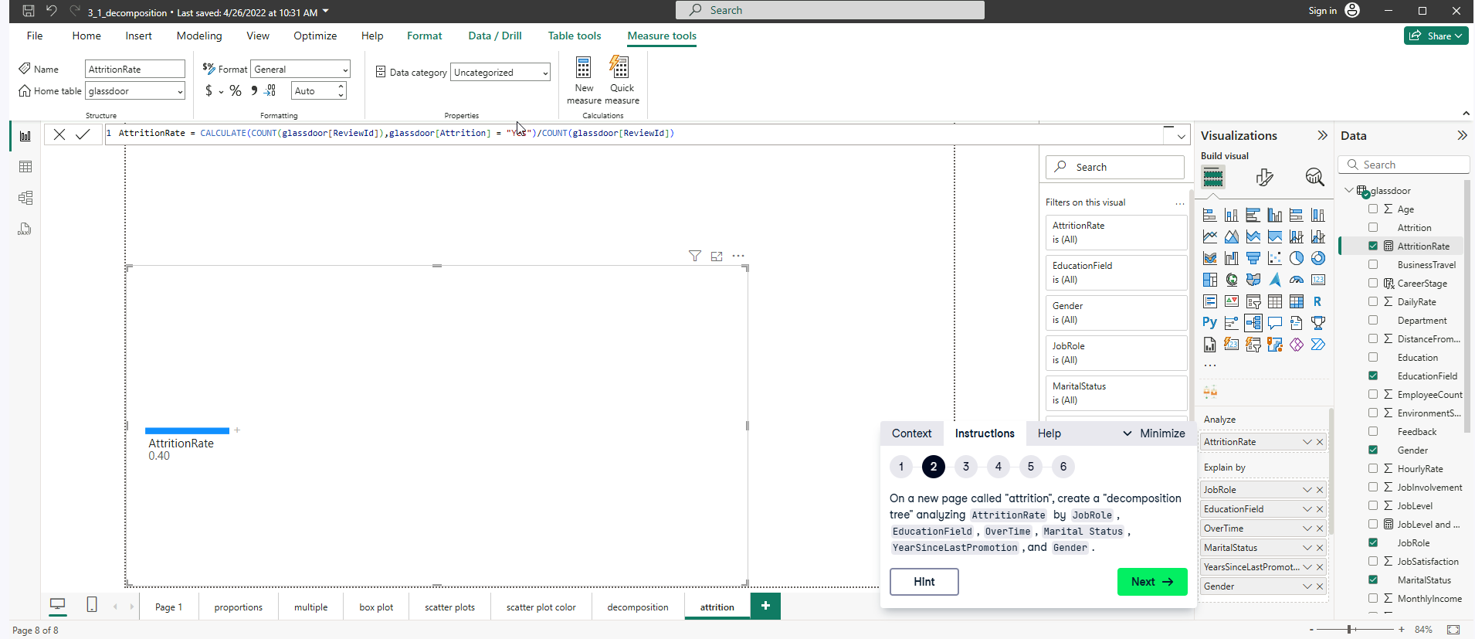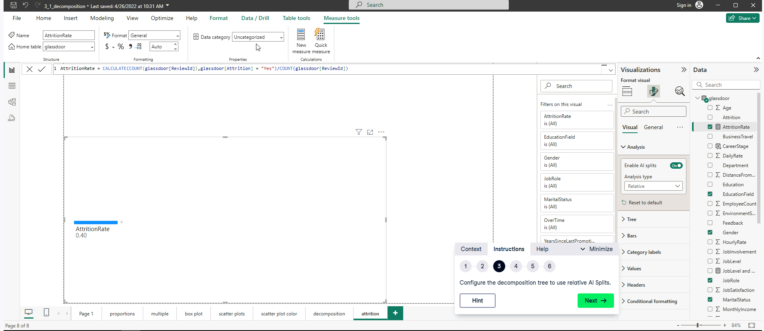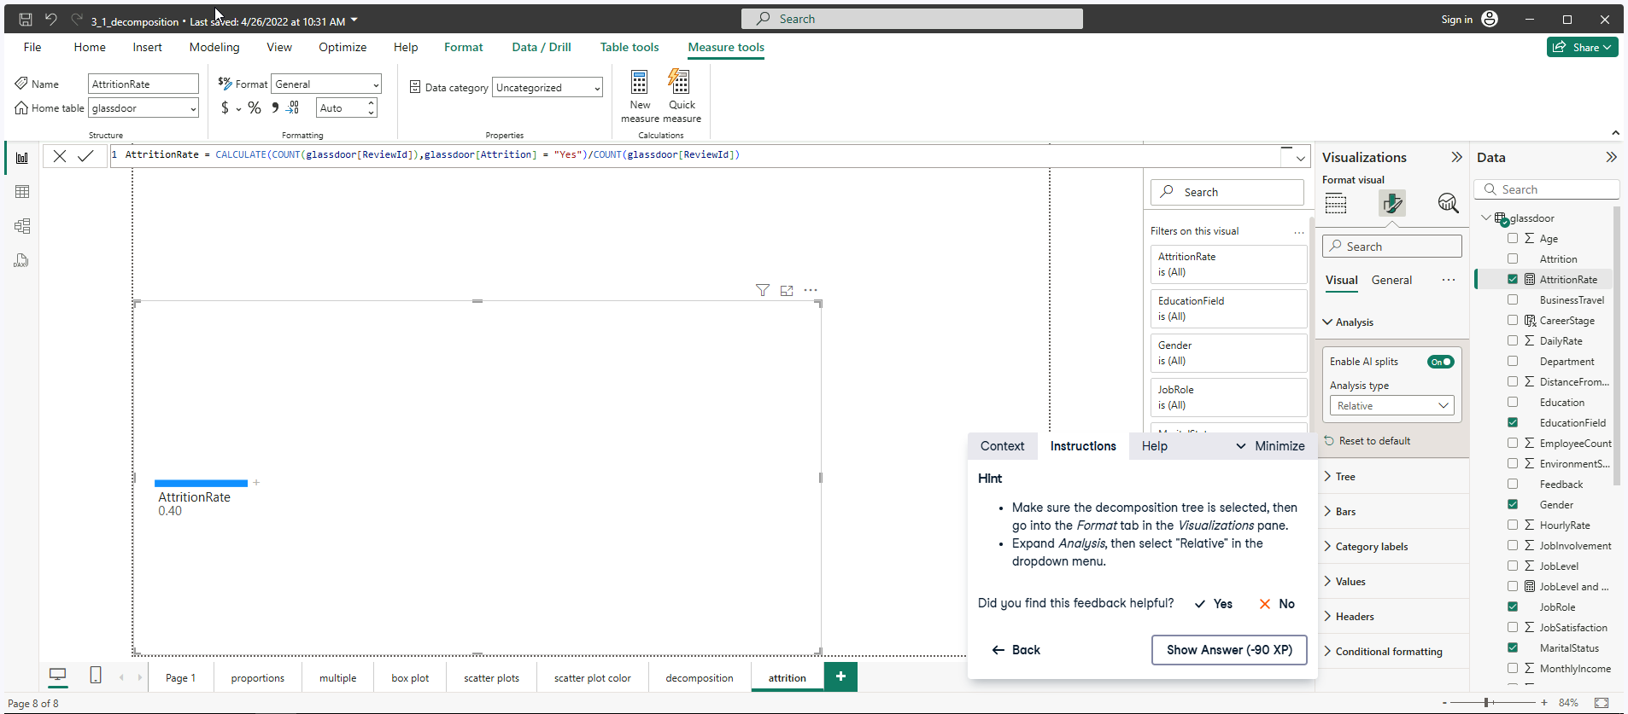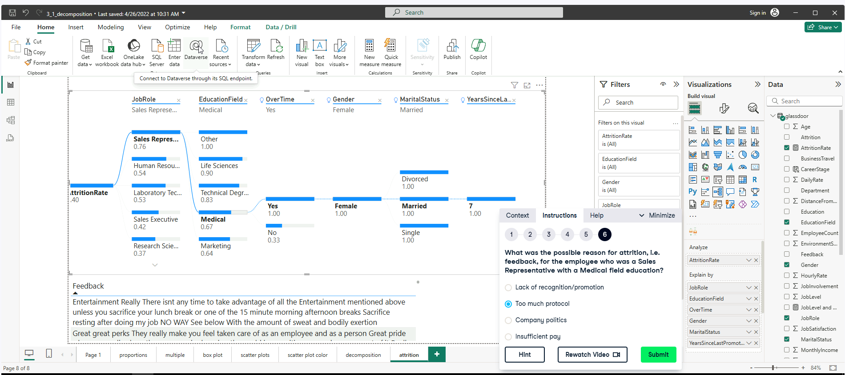

NOTE: Depends how well you interpret the question.

**Key Influencers**

**Exercise 4.2**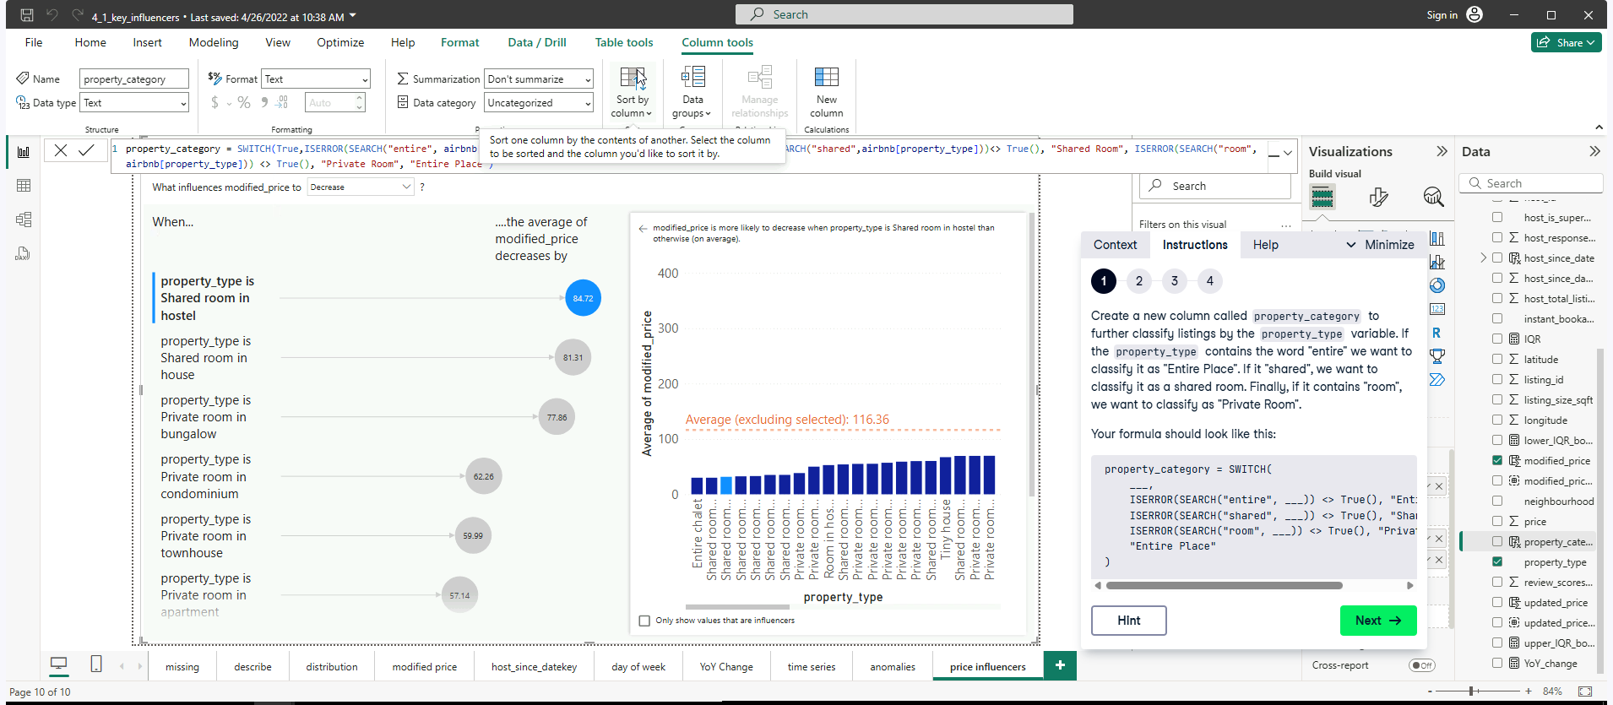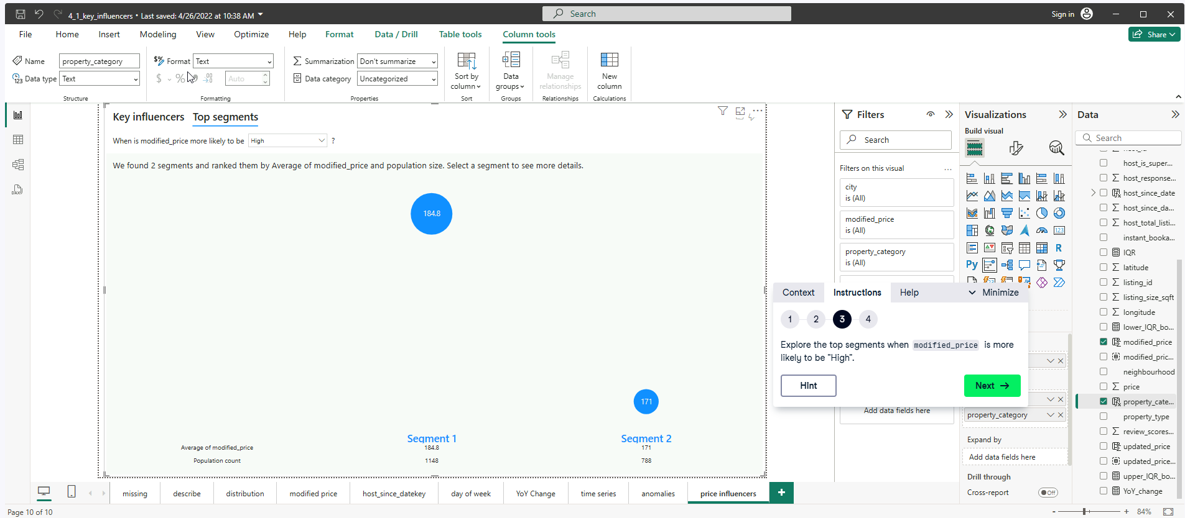

NOTE: It asks about the difference between the average modified price for Segment 1 and Overall in two decimal places (strict).

**Exercise 4.3**